ITEM | DESCRIPTIONS/CHARACTERISTICS | Qty | Visual
1 | PACK TO STUDY 1-PHASE AND –PHASE RECTIFICATION- IT INCLUDES :
1.1 | SELV POWER SUPPLY, DC AND 3 PHASES:  - Power supply : Mains (1P+N+E, 220 Vac- 50 Hz / 16 A)  OUTPUTS : 3-phase power supply 3 x 24 Vac 10 A + neutral, or DC 48 Vdc 9A, excitation 48 Vdc 2A,  A TFT screen coupled with a digital potentiometer diplays several measures : voltage, current, Cosϕ, Active power, reactive power. Answer to SELV standard (Safety Extra Low Voltage) | 4 | 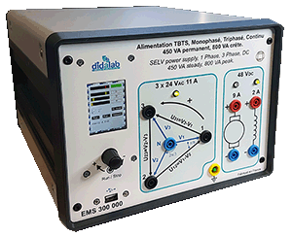  EMS300B
1.2 | Module for the study of 1-phase and 3-phase rectifiers, 300 W SELV:  We can study the following settings:  1-phase rectifiers : all diodes, mixed symmetrical, asymmetrical, all thyristors, assisted inverter  3-phase rectifiers : all diodes, mixed, all thyristors, assisted inverter  LEDs are used to see which power components are active.  There are voltage and current probes in each arm of the setting in order to display time curves for voltages and currents on a computer (computer not supplied)  A control software, operating with Windows is used to choose the setting to study, the probes to activate for signal display, firing angle for the thyristors ...  Supplied with practical works  Power: 300 W SELV (Safety Extra Low Voltage)  Power supply for the power part of the converter: AC: 3x24 Vac | 4 | 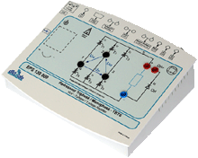  EPS130B
1.3 | Motor bench, SELV 300W, to be set on a table:  - Frame: The motor we want to study will be coupled with the load by soft fluted joins, and put on an aluminium frame.  - Load:Brushless motor controlled by an industrial variator.  - A control board and its power supply carries out the load generation and the acquisition of results (constant load, load according to speed, to square speed …)  Motor to be studied:  * DC motor, SELV 300W, permanent excitation (48 Vdc) 6,3A, | 4 | ELS322B  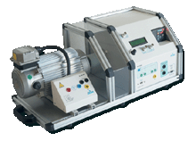
1.4 | Resistive load  Rheostats, 11 Ohms 9,3 A | 4
1.5 | Inductive load  Selfs 30mH 5An with protection fuse | 4
1.6 | Set of 25 SAFETY PATCH CORDS, 20 A, stackable | 4
2 | PACK TO STUDY CHOPPERS (SERIAL, 2 QUADRANTS, 4 QUADRANTS) AND INVERTERS (1-PHASE, 3-PHASE)- IT INCLUDES :
2.1 | SELV POWER SUPPLY, DC AND 3 PHASES:  - Power supply : Mains (1P+N+E, 220 Vac- 50 Hz / 16 A)  OUTPUTS : 3-phase power supply 3 x 24 Vac 10 A + neutral, or DC 48 Vdc 9A, excitation 48 Vdc 2A,  A TFT screen coupled with a digital potentiometer diplays several measures : voltage, current, Cosϕ, Active power, reactive power. Answer to SELV standard (Safety Extra Low Voltage)  Rheostat for energy evacuation: 33 Ohms, 960 W. | 4 | EMS300C
2.2 | Module for the study of choppers, 1-phase and 3-phase inverters, 300 W SELV  We can study the following settings:  Choppers: serial, voltage reversible, current reversible, 4-quadrants, overfitted double serial (+E /0 /–E )  1-phase inverter: shift control full wave with fixed frequency, with variable frequency, PWM +E/-E, +E/0/-E, constant U/F ratio.  3-pahse inverters : PWM with variable modulation incex, variable frequency, constant U/F ratio, PWM +E/-E, +E/0/-E  LEDs are used to see which power components are active.  There are voltage and current probes in each arm of the setting in order to display time curves for voltages and currents on a computer (computer not supplied)  A control software, operating with Windows is used to choose the setting to study, the probes to activate for signal display, the operating frequency, the duty cycle...  Supplied with practical works  Power: 300 W SELV (Safety Extra Low Voltage)  Power supply for the power part of the converter: DC: min 24 Vdc ; max 48 Vdc | 4 | EPS230B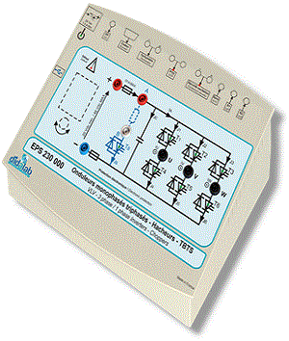
2.3  2.3.1  2.3.2  2.3.3 | Motor bench, SELV 300W, to be set on a table:  - Frame: The motor we want to study will be coupled with the load by soft fluted joins, and put on an aluminium frame.  - Load:Brushless motor controlled by an industrial variator.  - A control board and its power supply carries out the load generation and the acquisition of results (constant load, load according to speed, to square speed …)  Motors to be studied:  * DC motor, SELV 300W, permanent excitation (48 Vdc) 6,3A,  * 3-phase squirrel asynchronous motor, SELV 300 W, star/delta coupling ; 3 x 24/42 V_{AC}.  * Brushless motor, SELV 300 W, 48 Vdc |  | 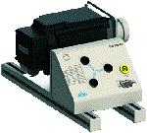  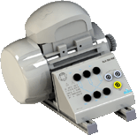  ELS323B+ ELS302000+ ELS306000
2.4 | Resistive load  Rheostats, 11 Ohms 9,3 A | 8
2.5 | Inductive load  Selfs 30mH 5An with protection fuse | 8
2.6 | Set of 25 SAFETY PATCH CORDS, 20 A, stackable | 4
 | environment
3 | HAND MULTIMETER, TRMS,  - LCD colour * screen, 100 000 points, frequency measure: 10 Hz / 5MHz,  - Voltage: DC / AC 10 mV to 1000 V,  - Current: DC/ AC 1 mA to 10A,  - Resistance : 100 Ω to 50 MΩ, capacitance : 1 nF to 10 mF, diode tester,  - 4-th order 300 Hz low pass PWM filter, duty cycle | 2 | 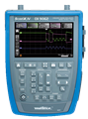  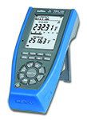
4 | DIGITAL OSCILLOSCOPE, 60 MHz 12 bits, 25 GS/s in ETS mode, 1 G S/s in 1-shot mode:  - 2 or 4 channels with floating grounds,  - « real time » FFT analysis  - TRMS multimeter, 8000 points 50 kHz,  - Black and white touch screen,  - RS232, Ethernet with web server  - Delivered with power supply, packing case, BNC/Ø4-mm adapters. | 8
5 | CURRENT PROBE,  - 20 A TRMS, Gain: 100 mV/A, Frequency 0 to 100 kHz, cable size up to 19 mm. | 2 | 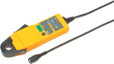
6 | DESK COMPUTER  Core processor 2 dual 2,93 GHZ Intel, HD : 250 GB, 3Gbit/s, DRAM 1 GB DDR3, 8 USB ports, 3 X Ethernet, DVD r/w 16X, 19” screen, keypad, mousepad, Windows PRO | 8
7 | WORKSTATION FOR SUTDENTS  - 1 electronic worktable, 200x100 cm, h 850 cm, feet  Work surface with high temperature protection,  Electrical panel : 16A circuit breaker, 30mA C curve differential circuit breaker, On/Off switch button, 8 electic plugs, 230V 16A,  - 2 seats | 8

