ITEM | DESCRIPTION / SPECIFICATION | QTY | REF and look of the product
1 | SET FOR THE STUDY OF 1-PHASE AND 3-PHASE RECTIFIERS, made of:
1.1 | LV POWER SUPPLY, DC AND 3 PHASES, 450 W:  - Power supply : Mains (1P+N+E, 220 Vac- 50 Hz / 16 A)  OUTPUTS :  3-phase power supply 3 x 220 Vac 2 A + neutral,  or DC 48 Vdc 9A,  excitation 48 Vdc 2A,  A TFT screen coupled with a digital potentiometer diplays several measures : voltage, current, Cosϕ, Active power, reactive power. | 1 | EM300B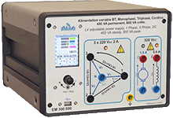
1.2 | Module for the study of 1-phase and 3-phase rectifiers, 300 W low voltage:  We can study the following settings:  1-phase rectifiers : all diodes, mixed symmetrical, asymmetrical, all thyristors, assisted inverter  3-phase rectifiers : all diodes, mixed, all thyristors, assisted inverter  LEDs are used to see which power components are active.  There are voltage and current probes in each arm of the setting in order to display time curves for voltages and currents on a computer (computer not supplied)  A control software, operating with Windows is used to choose the setting to study, the probes to activate for signal display, firing angle for the thyristors ...  Supplied with practical works | 1 | 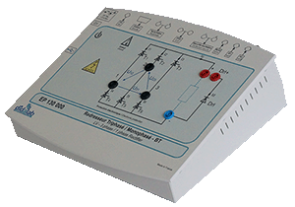  EP130B
1.3 | Motor bench, LV 300W, to be set on a table:  - Frame: The motor we want to study will be coupled with the load by soft fluted joins, and put on an aluminium frame.  - Load:Brushless motor controlled by an industrial variator.  - A control board and its power supply carries out the load generation and the acquisition of results (constant load, load according to speed, to square speed …)  Motors to be studied:  - DC motor 170 VDC 1.8 A with permanent excitation | 1 | EL322B  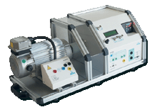
1.4 | Resistive load  210 Ohms 1,2 A with protective fuse | 1 | ELD050000
1.5 | Set of 25 SAFETY PATCH CORDS, 20 A, stackable | 1
2 | SET FOR THE STUDY OF CHOPPERS, made of:
2.1 | LV POWER SUPPLY, DC AND 3 PHASES, 450 W:  - Power supply : Mains (1P+N+E, 220 Vac- 50 Hz / 16 A)  OUTPUTS :  3-phase power supply 3 x 220 Vac 2 A + neutral,  or DC 48 Vdc 9A,  excitation 48 Vdc 2A,  A TFT screen coupled with a digital potentiometer diplays several measures : voltage, current, Cosϕ, Active power, reactive power.  Rheostat for energy evacuation: 33 Ohms, 960 W. | 1 | EM300C
2.2 | Module for the study of choppers and 1-phase inverters, 300 W, low voltage:  We can study the following settings:  Choppers: serial, voltage reversible, current reversible, 4-quadrants, overfitted double serial (+E /0 /–E )  1-phase inverter: shift control full wave with fixed frequency, with variable frequency, PWM +E/-E, +E/0/-E, constant U/F ratio.  LEDs are used to see which power components are active.  There are voltage and current probes in each arm of the setting in order to display time curves for voltages and currents on a computer (computer not supplied)  A control software, operating with Windows is used to choose the setting to study, the probes to activate for signal display,.the operating frequency, the duty cycle  Supplied with practical works | 1  . | 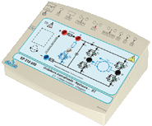  EP210B
2.3 | Motor bench, LV 300W, to be set on a table:  - Frame: The motor we want to study will be coupled with the load by soft fluted joins, and put on an aluminium frame.  - Load:Brushless motor controlled by an industrial variator.  - A control board and its power supply carries out the load generation and the acquisition of results (constant load, load according to speed, to square speed …)  Motors to be studied:  - DC motor 170 VDC 1.8 A with permanent excitation | 1 | EL322B
2.4 | Self load  30mH 5A with protective fuse | 1 | ELD102000
2.5 | Resistive load  210 Ohms 1,2 A with protective fuse | 1 | ELD050000
2.6 | Set of 25 SAFETY PATCH CORDS, 20 A, stackable | 1
3 | SET FOR THE STUDY OF 1-PHASE AND 3-PHASE INVERTERS, made of:
3.1 | LV POWER SUPPLY, DC AND 3 PHASES, 450 W:  - Power supply : Mains (1P+N+E, 220 Vac- 50 Hz / 16 A)  OUTPUTS :  3-phase power supply 3 x 220 Vac 2 A + neutral,  or DC 48 Vdc 9A,  excitation 48 Vdc 2A,  A TFT screen coupled with a digital potentiometer diplays several measures : voltage, current, Cosϕ, Active power, reactive power.  Rheostat for energy evacuation: 33 Ohms, 960 W. | 1 | EM300C
3.2 | Module for the study of choppers, 1-phase and 3-phase inverters, 300 W, low voltage:  We can study the following settings:  Choppers: serial, voltage reversible, current reversible, 4-quadrants, overfitted double serial (+E /0 /–E )  1-phase inverter: shift control full wave with fixed frequency, with variable frequency, PWM +E/-E, +E/0/-E, constant U/F ratio.  3-pahse inverters : PWM with variable modulation incex, variable frequency, constant U/F ratio, PWM +E/-E, +E/0/-E  LEDs are used to see which power components are active.  There are voltage and current probes in each arm of the setting in order to display time curves for voltages and currents on a computer (computer not supplied)  A control software, operating with Windows is used to choose the setting to study, the probes to activate for signal display,.the operating frequency, the duty cycle  Supplied with practical works | 1 | EP230B  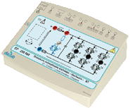
3.3 | Motor bench, LV 300W, to be set on a table:  - Frame: The motor we want to study will be coupled with the load by soft fluted joins, and put on an aluminium frame.  - Load:Brushless motor controlled by an industrial variator.  - A control board and its power supply carries out the load generation and the acquisition of results (constant load, load according to speed, to square speed …)  Motors to be studied:  - 300-W AC 3-phase motor, star delta 3 x 240/400 VAC,  - 300-W Brushless motor | 2 | 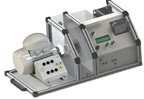EL323,6B  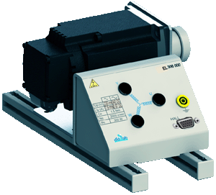
3.4 | Self load  30mH 5A with protective fuse | 3 | ELD102000
3.5 | Resistive load  210 Ohms 1,2 A with protective fuse | 3 | ELD050000
3.6 | Set of 25 SAFETY PATCH CORDS, 20 A, stackable | 2
3.7 | PLC and Didactised Industrial Drive for 300-W 3-phase Asynchronous motor  The industrial componants of this package are put in a cube.  The 4 useful sides:  - 1 side with the power supply socket  - 1 HMI interface side, type KTP 700, graphic 7’, KTP700, with a WEB Server function for the connection of several computers simulatneously  - 1 Siemens Drive side, type SIMATICS G120C 0.55 kW, with graphic terminal for asynchronous motor  - 1 PLC side, SIMATIC S7 1200 | 1 | EST110  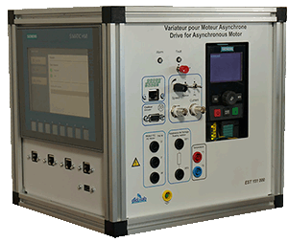
3.8 | PLC and Didactised Industrial Drive for 300-W Brushless motor  The industrial componants of this package are put in a cube.  The 4 useful sides:  - 1 side with the power supply socket  - 1 HMI interface side, type KTP 700, graphic 7’, KTP700, with a WEB Server function for the connection of several computers simulatneously  - 1 Siemens Drive side, type SIMATICS V90, with graphic terminal for Brushless motor  - 1 PLC side, SIMATIC S7 1200 | 1 | EST120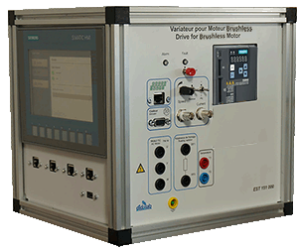
4 | SET FOR THE STUDY OF 1-PHASE AND 3-PHASE AC-CONTROLLERS, made of::
4.1 | LV POWER SUPPLY, DC AND 3 PHASES, 450 W:  - Power supply : Mains (1P+N+E, 220 Vac- 50 Hz / 16 A)  OUTPUTS :  3-phase power supply 3 x 220 Vac 2 A + neutral,  or DC 48 Vdc 9A,  excitation 48 Vdc 2A,  A TFT screen coupled with a digital potentiometer diplays several measures : voltage, current, Cosϕ, Active power, reactive power. | 2 | EM300B
4.2 | Module for the study of 1-phase and 3-phase AC-controllers, 300 W, low voltage:  We can study the following settings:  1-phase AC- controller:  - Phase angle,  3-phase AC- controller:  - Phase angle,  LEDs are used to see which power components are active.  There are voltage and current probes in each arm of the setting in order to display time curves for voltages and currents on a computer (computer not supplied)  A control software, operating with Windows is used to choose the setting to study, the probes to activate for signal display, firing angle for the thyristors ...  Supplied with practical works | 2 | EP120B  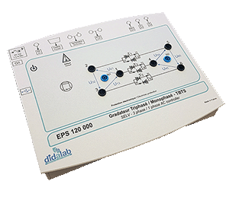
4.3 | Self load  30mH 5A with protective fuse | 6 | ELD102000
4.4 | Resistive load  210 Ohms 1,2 A with protective fuse | 6 | ELD050000
4.5 | Set of 25 SAFETY PATCH CORDS, 20 A, stackable | 2
 | environment
5 | HAND MULTIMETER, TRMS,  - LCD colour * screen, 100 000 points, frequency measure: 10 Hz / 5MHz,  - Voltage: DC / AC 10 mV to 1000 V,  - Current: DC/ AC 1 mA to 10A,  - Resistance : 100 Ω to 50 MΩ, capacitance : 1 nF to 10 mF, diode tester,  - 4-th order 300 Hz low pass PWM filter, duty cycle | 8 | 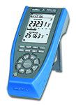  EMD200010
6 | DIGITAL OSCILLOSCOPE, 60 MHz 12 bits, 25 GS/s in ETS mode, 1 G S/s in 1-shot mode:  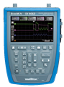  - 2 or 4 channels with floating grounds,  - « real time » FFT analysis  - TRMS multimeter, 8000 points 50 kHz,  - Black and white touch screen,  - RS232, Ethernet with web server  - Delivered with power supply, packing case, BNC/Ø4-mm adapters. | 8 | 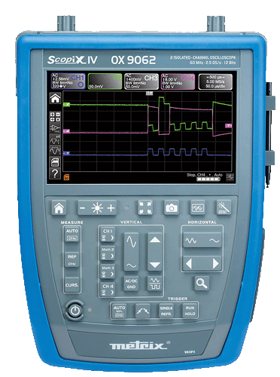  EMD022020
7 | CURRENT PROBE,  - 20 A TRMS, Gain: 100 mV/A, Frequency 0 to 100 kHz, cable size up to 19 mm. | 8 | 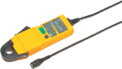
8 | DESK COMPUTER  Core processor 2 dual 2,93 GHZ Intel, HD : 250 GB, 3Gbit/s, DRAM 1 GB DDR3, 8 USB ports, 3 X Ethernet, DVD r/w 16X, 19” screen, keypad, mousepad, Windows PRO | 8
9 | WORKSTATION FOR SUTDENTS  - 1 electronic worktable, 200x100 cm, h 850 cm, feet  Work surface with high temperature protection,  Electrical panel : 16A circuit breaker, 30mA C curve differential circuit breaker, On/Off switch button, 8 electic plugs, 230V 16A,  - 2 seats | 8 | EMO100B

