Item | DESIGNATIONS/CHARACTERISTICS | Qty | Picture
1 | Speed & position servosystems on DC motor  - 1 electromechanical unit with DC motor (24 Vdc, power 13 W, 4800 rd/min, Torque cste 42.4 mNm/A, starting current inferior to 140 mA), signal encoder in quadrature, 100 pts per turn at the end of the axis ; 1 load via generator at the end of the axis with graduated disc at the front.. The disturbance are applied to the generator and can be : dry friction, constant torque, torque depending of the speed, of the sqare speed, inertia ...  It can be current controlled or voltage controlled,. USB interface for the link to the computer (computer not included)  The software (Windows Pro friendly) enables the selection of :  - The system structure : open loop/closed loop, speed or position,  - The control type & the characteristic values : constant step, ramp, sine, trapezoid, external,  - The corrector : P, PI, PD, PID with parameters adjustments, « Z » corrector as an optional extra  - The time response display of one (or several) characteristic magnitude(s) : position, speed, acceleration, motor current, motor voltage, set value, gap, corrector output, etc  - The assistance to the measurement of typical values in automatic control: time constant, overshoot, stabilisation at 5%, harmonic calculation, sinusoidal.  Supplied with its power supply, 2 sets of complete experiments (book for the teacher + book for the student). | 2 | 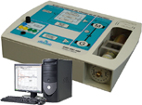
2 | Study & proficiency in speed & position digital & analogue servosystems  Electromechanical device on table-top anodized aluminium baseframe, with external power supply.  DC motor, (24 Vdc, 19 W 4000 tr/min, torque 43.8 mNm/A)  "Mechanical device allows load parameters separate variations : adjustable (even cancelable) dry friction, adjustable, (even cancelable) fluid friction, adjustable inertia.  The electronic control board is equipped with high level power microprocessor, for carrying out the system real time control and the communication PC computer (USB link).  The software (Windows Pro friendly) enables the selection of :  - The system structure : open loop/closed loop, speed or position,  - The control type & the characteristic values : constant step, ramp, sine, trapezoid, external,  - The corrector : P, PI, PD, PID, Z digital with parameters adjustments,  - The time response display of one (or several) characteristic magnitude(s) : position, speed, acceleration, motor current, motor voltage, set value, gap, corrector output, etc  - The assistance to the measurement of typical values in automatic control: time constant, overshoot, stabilisation at 5%, harmonic calculation, sinusoidal.  - Optional extra « Automatic real time corrector generator», Begining with the creation of a model with freeware Scilab/Xcos, the creation of a new corrector in graphic mode, then generation of the corrector in C language and implementation in the opertating part. Comparison between simulation and reality.  Supplied with USB cable, power cable and practical works (teacher and student). | 2 | 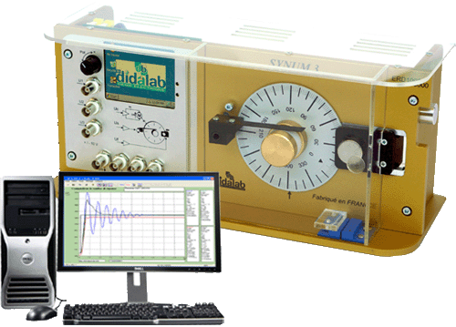
3 | « DIGITAL AXIS », SPEED and POSITION SERVO CONTROL, made of:  Tit is an electromechanical device ; it can be put in horizontal or vertical position (influence of gravity study).  Power is supplied by external transformer.  Control part  An electronic control board is equipped with high level power microprocessor carries out the system real time control and  the communication PC computer (USB link, RS232 on request).  An electronic power board carries out the motor driving interfacing and the other interfaces, used in the axis control. Two  controls are available: current or voltage.  Operating part  It includes a support beam on which moves a movable carriage. On it, is fixed a geared DC with a 2-channel incremental  encoder.  The movement transmission is effected by rack and pinion  The software (Windows Pro friendly) enables the selection of :  - The system structure : open loop/closed loop, speed or position,  - The control type & the characteristic values : constant step, ramp, sine, trapezoid, external,  - The corrector : P, PI, PD, PID, Z digital with parameters adjustments,  - The time response display of one (or several) characteristic magnitude(s) : position, speed, acceleration, motor current, motor voltage, set value, gap, corrector output, etc  - The assistance to the measurement of typical values in automatic control: time constant, overshoot, stabilisation at 5%, harmonic calculation, sinusoidal.  - Optional extra « Automatic real time corrector generator», Begining with the creation of a model with freeware Scilab/Xcos, the creation of a new corrector in graphic mode, then generation of the corrector in C language and implementation in the opertating part. Comparison between simulation and reality.  Supplied with USB cable, power cable and practical works (teacher and student). | 3 | 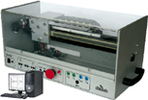
4 | TRAINING SYSTEM OF AIR TEMPERATURE & FLOW SIMPLE PROCESS CONTROL, FLOW CASCADE & AIR TEMPERATURE  It is composed of :  - A actuator part for flow process control (turbine, 4/20 mA flow sensor, time constant of about 390 ms) and temperature control (heating resistances 2 powers, PT100 4/20 mA temperatrue sensor, time constant 22 s), disturbance of the flow is done with a flap.  - A control panel displays a didactic mimic-layout, with all necessary connections for linking sensors and actuators, and built-in power supply.  The software (Windows Pro friendly) enables  - the study of P, I, D, correctors, Z transform, fuzzy logic, dead time compensation, development of new correctors  - Study of the current loop,  - Test in Open Loop of an air flow control ; Test in Open Loop of temperature control on air flow,  - Flow control with corrector : P, P I, PID, Z transform ; Air temperature control with corrector : P, P I, PID, Z transform, by negative action on the flow, cascade & dual loop,  - Simulation of a process.  - Optional extra « Automatic real time corrector generator», Begining with the creation of a model with freeware Scilab/Xcos, the creation of a new corrector in graphic mode, then generation of the corrector in C language and implementation in the opertating part. Comparison between simulation and reality.  Supplied with its power supply, 2 sets of complete experiments (book for the teacher + book for the student). | 2 | 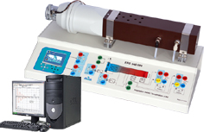
5 | Air Pressure Industrial Process Control Unit  It Is Composed Of :  A actuator part for air pressure process control (time constant : about 10s), with a experiment chamber of 1000 cm³,  The control pannel is included. It displays a didactic mimic-layout, with all necessary connections for linking sensors and actuators, and built-in power supply.  Compatible with all controllers providing 4/20 mA Inputs/Outputs  The Software (Windows Pro Friendly) Enables  The study of P, I, D, correctors, Z transform, fuzzy logic, dead time compensation, development of new correctors  Study of the current loop,  The assistance to the measurement of typical values in automatic control: time constant, overshoot, stabilisation at 5%, harmonic calculation, sinusoidal.  Supplied with its power supply, 2 set of complete experiments (book for the teacher + book for the student) | 1 | 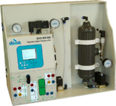
6 | WORKSTATION FOR SUTDENTS  - 1 electronic worktable, 200x100 cm, h 850 cm, feet  Work surface with high temperature protection,  Electrical panel : 16A circuit breaker, 30mA C curve differential circuit breaker, On/Off switch button, Emergency pushbutton; 3x3 electic plugs, 230V 16A,  - 2 seats | 8
7 | DESK COMPUTER  Core processor 2 dual 2,93 GHZ Intel, HD : 250 GB, 3Gbit/s, DRAM 1 GB DDR3, 8 USB ports, 3 X Ethernet, DVD r/w 16X, 19” screen, keypad, mousepad, Windows PRO | 8
8 | DIGITAL Oscilloscope, 100 mhz  2 X 100 MHz, TFT digital display, time base: 5ns to 50s, 500MS/s, Auto/normal/monocoup trigger, coupling A, DC, LF, HF, noise rejection, auto-calibration,  Supplied with 2 probes  150 MHz, ratio 1/1, 1/10, 10 MOhms, 10 to 30 pF | 4  4 | 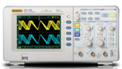
9 | hand Multimèter, 4000 points  Voltage: DC and AC up to 600 V  Current: DC and AC up to 10 A  Resistance : up to 40 MOhm | 2 | 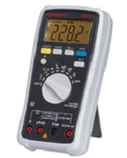
10 | LF function generator, wITH DIGITAL DISPLAY, 10 mHz 5 mhz,  Signals : sine, square, saw,  0 to 20 V pp without load, 0 to 10 V with 50 Ohms  Duty cycle adjustable between 20 to 80 % - intern wobulation: LIN or LOG  TTL output  Frequency meter up to 50 MHz | 2 | 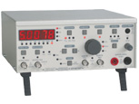
11 | Compressor Low noise, 40 dBa, 8 bars, 3m3/h, 9l, accessories | 1
12 | BNC PATCH CORDS  BNC/BNC cords, 50 Oms, 1 m,  BNC/4-mm sockets adapter | 8  8

