Item | DESCRIPTIONS/CHARACTERISTICS | Qty | Product preview
1 | TRAINER FOR ANALOGUE ELECTRONICS  This trainer allows the study of :  Training on basic assemblies enabling the carrying out of a stabilised Power Supply : Single wave monophase rectifier bridge, Dual waves monophase rectifier bridge, Monophase Graetz bridge, Capacitor filtering, Voltage control by follower transistor assembly & Zener voltage reference.  - Training on transistors amplifier,  - Training on transistors multivibrator,  - Training on Operational Amplifier basic circuits : Follower assembly, Amplifier assembly, Integrator assembly, Derivator assembly.  - Training on filters : Low-pass filters, High-pass filters, Band-pass filters.  The Monitor provides : One dual Power Supply +/-12 VDC fixed voltage & 15 VAC and One dual Power Supply +/- 0/10 VDC variable voltage & dc, individually adjustable.  Supplied with its power supply and books of practicals (1 for the teacher, 1 for the students) | 8 | 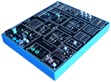
2 | A/D CONVERSION TRAINER  shows the operation of :  - Sample & hold unit,  - Single & double ramp converters,  - Counting converters,  - Built-in converters.  The module includes one counting and display unit as well as one quartz clock with different use frequencies.  Supplied with its power supply and 1 book of practical works | 4 | 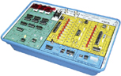
3 | D/A CONVERSION TRAINER  allows the study of different Digital / Analog conversion modes :  - DAC with weighted resistors (8 bits)  - DAC with R/2R network (8 bits)  - Counting DAC (8 bits)  - Built-in DAC (8 bits)  Besides converters, all auxiliary functions necessary to the proposed studies are located on the module:  Clock, reference voltage, filter, amplifier, counter, …  Supplied with a power supply and 1 book of practical works | 4 | 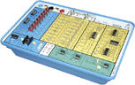
4 | SET OF 2 TRAINERS (1 TRANSMITTER + 1 RECEIVER) FOR THE STUDY OF OPTO ELECTRONIC SENSORS  Study of the main opto electronics sensors, applications as:  - light gates,  - data transmissions,  - fiber optics telephone,  - generation & detection of light pulses,  - sound transmission by optic fiber,  - digital data transmission,  - study of transmission environment.  - Supplied with a power supply and 1 book of practical works | 2 | 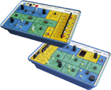
5 | TRAINER FOR THE STUDY OF MAGNETIC CIRCUITS  - Study of several magnetic circuits: iron core transformer, ferrite core transformer, pulse transformer.  - study of several magnetic circuits : iron core transformer, ferrite core transformer, pulse transformer.  Typical experiments:  - inductance measurement of ferrite core circuit,  - hysteresis cycle,  - flyback power supply.  Supplied with a power supply and 1 book of practical works | 2 | 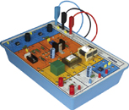
6 | TRAINER FOR THE STUDY OF CORE TRANSFORMERS  This trainer is composed of 2 core transformers : iron and ferrit. It allows:  - plotting of hysteresis cycles with variable frequency 0.2 Hz to 500 Hz with a built-in power amplifier  - curve of first magnetizing with ramp generator  A built-in multiplier allows display of power set in primary or secondary  A low-pass filter associated to multiplier allows obtention of mean power  Supplied with a power supply and 1 book of practical works | 2 | 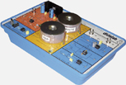
7 | TRAINER FOR THE STUDY OF SWITCHING POWER SUPPLIES  Switching power supplies module, enabling the study of the following functions:  - flyback power supply,  - forward power supply,  - push pull power supply,  - inductive & capacitive storage choppers.  Supplied with a power supply and 1 book of practical works | 2 | 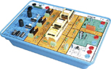
8 | trainer for the study of signal processing :  1 Module for signal processing based on doble core DSP.  Description of the Input and Output functions:  - 2 Broadband Inputs:  A/D pipeline converters, 16 bits 1 MHz, +/- 10Vdc.  - 2 Broadband outputs:  D/A converters 12 bits 100 KS/s +/-10Vdc  - 2 On/Off Inputs and Outputs,  - One set of connectors to connect the extension modules  - 2 HDMI connectors,  - 2 Codecs (Line in, Line out, microphone input, loudspeakers output),  Graphic and textual editor :  - Very large library (400 graphic functions, customizable (arithmetic, continuous, non linear, telecommunications, matrix, baseband, control, filters, etc.),  - Possibility of enriching the library by creating your own graphic functions,  - Switch from textual mode to graphic mode, multi windows,  - Immediate detection of errors (short-circuit, connections between 2 inputs, connections between incompatible modules,  Power supply : 240V  Set of accessories (USB patch cord, microphone, 2 stereo speakers, 2 BNC patch cords)  Supplied with booklets of practical works, with practical works about analogue electronics, digital electronics, analogue and digital modulations, analogue and digital filters …. | 8 | 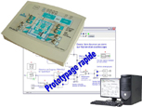

9 | SET OF 2 TRAINERS (BASIC COMBINATORY /SEQUENTIAL LOGIC)  The 1st logic training board enables the study of the basic combinatory or sequential logic (AND, OR, NOT, XOR, RS & JK flip-flops, ...)  Different technologies are available, discrete components: RD (resistors, diodes), DTL (digital transistors diodes) & TTL integrated circuits.  Mimic layouts displayed are similar to the industrial datasheet diagrams.  Combinatory logic with discrete components : 2 resistors, 3 diodes, 1 transistor (carrying out of functions: AND, OR, NOR, NAND based on D & DT technology),  Combinatory logic with TTL technology : 6 NOT, functions with 2 inputs, 8 AND, 8 NAND, 8 OR, 8 NOR, 4 WOR, 3 NOR with 3 inputs, functions with 3 inputs, 3 NAND, 3 NOR  Flip-flops :- 2 RS flip-flops, 2 RSH flip-flops, 2 D flip-flops, 4 JK flip-flops,  The 2nd board is an extension module of the first combinatory logic simulator.  It enables the study of combinatory circuits, such as: amplifiers, open collectors & three states logic; then the digital functions: comparators, shift registers, up & down counters, ALU.  Amplification function : 4 NAND with 2 inputs, open collector & 4 pull-up resistors, 2x 4 buffers (3 states) grouped common control,  Digital : 2 demultiplexer circuits, 2 to 4, 2 multiplexer circuits, 4 to 1, 1 parallel / serial shift register, 1 programable up & down counter, 1 ALU, Arythmetic Logic Unit, 8 operations (set, reset, addition, substraction A-B & B-A, - OR, AND, XOR),  Service  - 1 potentiometer,  - 1 bounce-free pushbutton, 1 pushbutton to be bounce-free processed (as an experiment),  - 8 +3 logic state generators, 8 LED display devices,  - 7-segments display device with decoder,  - 1 fixed clock: 1 kHz, 1 variable clock: 100 Hz to 2 kHz  Supplied with its power supply and complete experiments (questions & solutions) : 4 book of practical works (2 for the teacher, 2 for the students) | 8 | 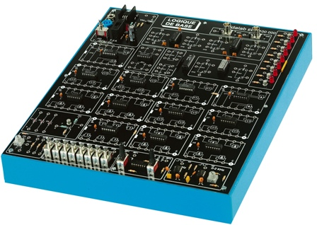  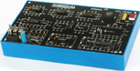

10 | SIMULATOR & LOGIC CIRCUIT TEST MONITOR  It is designed for enabling the basic training on logic functions.  It is equipped of 4 zero insertion sockets. The student plugs the components to be studied into the socket, all connections are achieved by 2 mm patching leads & banana plugs."  4 zero insertion sockets with 2mm connection,  - 2* 16 pins, 7.62 mm sockets,  - 1* 28 pins, 7.62/15.24 mm sockets,  - 1* support 40 broches 7.62/15.24 mm,  The 7.62/15.24 mm sockets enable to put wide and/or narrow circuits,  Also :  - 2* 7 segments display with encoder,  - 12 switches for programming 0 or 1 levels,  - 2 bounce-free pushbuttons for practical works on flip-flops, counters and registers ,  - 1 adjustable clock : 0.1 Hz to 10 kHz (adjustement with pushbutton and fine adjustement with potentiometer),  - 12 display LEDs with transistor interface,  Supplied with 25 electronic logic components (AND, OR, XOR, NOR, NAD, flip-flps, counters, buffers, adder)  Supplied with its power supply | 4 | 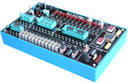
11 | Programmable logic trainer  This board enables the study of epld programable logic, as well as the operation & skill of the VHDL language (developed by lattice, trade mark).  For an easy maintenance, all components are plugged on sockets.  It is based on one EPLD mach4 circuit, with 44 pins, manufactured by lattice. It is provided with one VHDL edition & downloading program.  It includes :  - 5 level generator keys (4 counter inputs, 1 programing input)  - 1 bounce-free pushbutton (JK clock, counter)  - 4 LED display device  - 2 multiplexed 7 segments display devices  - 1 PC 104 standard connector enabling the study of this interface on the EID serial board or on any other available board  - 1 Centronics connector, 360 pins, JTAG standard  - 1 switchable clock: 2 hz, 2 khz  Test points are located around the component, in order to facilitate the reading of inputs/outputs on the oscilloscope.  - Supplied with its power supply and 2 books of practical works (1 for the teacher, 1 for the students) | 4 | 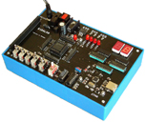

12 | WORKSTATION FOR SUTDENTS  - 1 electronic worktable, 200x100 cm, h 850 cm, feet  Work surface with high temperature protection,  Electrical panel : 16A circuit breaker, 30mA C curve differential circuit breaker, On/Off switch button, Emergency pushbutton; 3x3 electic plugs, 230V 16A,  - 2 seats | 8
13 | DESK COMPUTER  Core processor 2 dual 2,93 GHZ Intel, HD : 250 GB, 3Gbit/s, DRAM 1 GB DDR3, 8 USB ports, 3 X Ethernet, DVD r/w 16X, 19” screen, keypad, mousepad, Windows PRO | 8
14 | DIGITAL Oscilloscope, 100 mhz  2 X 100 MHz, TFT digital display, time base: 5ns to 50s, 500MS/s, Auto/normal/monocoup trigger, coupling A, DC, LF, HF, noise rejection, auto-calibration,  Supplied with 2 probes  150 MHz, ratio 1/1, 1/10, 10 MOhms, 10 to 30 pF | 8  8 | 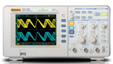
15 | hand Multimèter, 4000 points  Voltage: DC and AC up to 600 V  Current: DC and AC up to 10 A  Resistance : up to 40 MOhm | 8 | 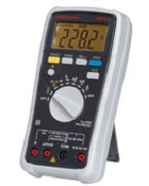
16 | LF function generator, wITH DIGITAL DISPLAY, 10 mHz 5 mhz,  Signals : sine, square, saw,  0 to 20 V pp without load, 0 to 10 V with 50 Ohms  Duty cycle adjustable between 20 to 80 % - intern wobulation: LIN or LOG  TTL output  Frequency meter up to 50 MHz | 8 | 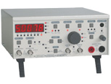
17 | Load rheostat  160 W – 100 Ohms | 6
18 | patch cordS  BNC/BNC cords, 50 Oms, 1 m,  BNC / 2x Ø 4-mm cords  BNC/Ø4-mm adaptes | 16  16  16

