Item | DESCRIPTIONS/CHARACTERISTICS | Qty | Product preview
1 | 8/16 BITS Microcontroller  Complete package for the study of the structure and programming of 68HC12 microcontrollers  Hardware:  - Architecture of one 8/16 bits micro-system, microprocessor-based, microcontroller, 68HC12 ( fully compatible 68HC11) 16 MHz clock,  - Storage: 256 Kbytes,EEPROM flash ,  - EEPROM 4 Kbytes,  - RAM 8 bits 12+ 128 Kbytes,  - Serial port : USB, RS232, SPI, I2C, CAN,  - 16 characters, ASCII LCD display device,  - 5 pads keypad / joystick,  - PC104 bus, giving access to many available Inputs / Outputs boards,  - 24 bits parallel port, 6 Analogue I & 4 O on HE10 40 pts, SPI port & I2C."  Software:  One Jtag probe enables to put the student in true industrial development situation, using the Warriorcode (trade mark of the Freescale C°), providing the following facilities:  - PC editor,  - Cross assembler,  - Cross compiler,  - Debugger monitor: hard breakpoint, condition breakpoint, C step-by-step, assembler, display of registers, storage area. "  - Input / output simulator board with 8 LEDs, 8 microswitches, 1 bounce-free pushbutton (interrupt input), 1 Potentiometer on analog input, 1 LED on analog output.  - Power supply : 220V – 50Hz , RS232 & USB leads | 2 | 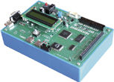
2 | 68332 microprocessor microcontroller study board & device  This System enable the study of microprocessors and micro controllers of the CPU32 range (68000 kernel, pipeline instructions, object optimised routine ...).  It includes :  68332 16/32 bits micro system, microprocessor-based, micro-controller, 16.7 MHz clock, RAM 128 Kbytes of 16 bits, ROM 128 Kbytes « flashs »,  - Port // 24 bits, 6 I & 4 O (analogue).  - PC104 bus giving access to many available inputs / outputs boards,  - Serial port: USB, RS232, SPI, I2C,  - C & C++ cross compiler, GNU with StDIO (Standard Data Input Output) libraries, debugger monitor (windows friendly)  - Input / output simulator board with 8 LEDs, 8 microswitches, 1 bounce-free pushbutton (interrupt input), 1 Potentiometer on analog input, 1 LED on analog output.  Supplied with power supply, patching boards, technical manual, manual of practicals | 4 | 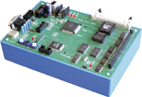
3 | TRAFFIC LIGHTS SIMULATOR  19 Inputs  - 1 Main road with 2 independent traffic lights, opposite roads, (2 Red's, 2 Yellow's, 2 Green's, 6 variables), 2 combined pedestrians lights, (1 Red, 1 Green), Left slip road, 2 independent lights, (2 Red's, 2 Yellow's, 2 Green's)  - 1 Secondary road with 2 combined lights, (1 Red, 1 Yellow, 1 Green), 2 associated pedestrians lights, (1 Red, 1 Green),  5 Outputs, variable (inputs for the micro-system)  - 1 pedestrian call for the main road, 1 pedestrian call call for the secondary road, 2 left slip road car detections, 1 secondary road car detectio)  Supplied with patching cord, power supply, manual of practicals (using assembler and C compiler) | 2 | 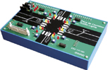
4 | Training unit of Industrial Local Networks applied to the car industry:  - One industrial board (ATON SYSTEM) carrying out the CAN interface,  - One ON/OFF, 8 inputs acquisition board (microswitches plugged on the board enable the simulation of the Comodo device),  - Four ON/OFF, 4 outputs boards ( LED's located on the output board enable the simulation & also the display of the optical blocks filament state),  - This unit enables to put the Student face up to the development situation. Progressive & full Practical Works with solutions are provided with the equipment. | 2 | 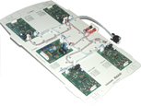
5 | Training unit of motor speed control (windscreen sweeper) through Industrial Local Network, CAN netwORK:  - - One industrial board (proposed by ATON SYSTEM), that carries out the CAN interface,  - - One motor / CAN speed control board, the motor + reducer+ encoder assembly, the winscreen sweeper assembly,  - - One input board (control of analogue signal, one potentiometer & microswitches enabling the simulation of the windscreen sweeper "commodo" device).  - This unit put the Student face to the development situation, progressive & complete Practical Works with solutions are provided together with the equipment. | 2 | 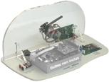
6 | Training Multiplexed Vehicle, complete version, it includes:  Training Multiplexed Vehicle, complete version, it includes :  - Frame representing a motor vehicle, turning lights handle, windscreen wiper handle; approx dim: L 130 cm, w : 90 cm, h : 50 cm  - 1 68332 32 bits microcontroller study board, (CPU32), clock: 16.7 MHz, USB port, RS232, PC104 bus, 24 bits parallel port, 6 D/A I & 4 D/A O, with editor, cross assembler linker, debugger, technical guide,  - 1 Inputs/Outputs simulator, with 40 points layer, USB leads, Power Supplies,  - 1 CAN bus board on PC 104,  - 1 board with 16 pads keypad & display device, 7 x 16 ASCII characters and/ or 128x64 monochrome graphic, with its PC104 layer,  - 1 CAN bus module, 8 ON/OFF inputs & one analogue input with bus lead, Supply & CAN,  - 1 CAN bus module, 4 ON/OFF outputs & 4 ON/OFF outputs with bus lead, Supply & CAN,  - 1 Car modelized socket, scale: 1/4, pre fitted out,  - 1 Set of industrial components: 1 light comodo, 2 front optical sets, 30W, sidelights/headlights/full lights, 2 indicators, 2 back optical sets stoplights/sidelights/indicators, horn, each module with its connectors,  - 1 CAN bus module motor servocontrol, motor/encoder, stand, CAN bus lead, Supply & 1 windscreen sweeper,  - 1 Ethernet board,10 Mbits, with TCP/IP cell, sockets, Web server, SPI bus, I2C.  - 1 C & C++ compiler,  - 1 MTR86 real time kernel (single-stand version)  Many Practicals are provided with the equipment. These Experiments enable a very didactical progression, from the discovery of the microcontroller, the control of inputs / outputs, serial (USB, CPI, I2C), parallel, to the skill of one CAN Industrial Local Network, applied to the Car Industry, speed control, implementation of one integrated Web server. | 1 | 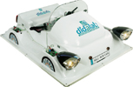
7 | 3 levels hoist model, 21 ON/OFF Inputs / Outputs  3 levels hoist model, 21 On/Off inputs / outputs, grafcet sequential control:  Compatible with any Programable Logic Controller(PLC) having inputs / outputs from 5 to 24 Vdc, common point to + or -  13 outputs (PLC or PC inputs) :  3 car calls, located on the vertical front panel, 3 car calls (inside the car, located on the control panel), 3 detectors with car presence display, emergency stop with display, car overweight detection , car driving motor voltage & current images,  Inputs (PLC or PC outputs) :  3 car calls display, 1 up control, 1 down control, 3 floor calls display.  Provided with the simulator grafcet editor & interpreter: "Mentorgraf" :  - operation in execute mode with variable display.  - Grafcet graphic edition, steps, transitions, and / or divergences, macro steps, front conditional actions, internal variables, time delays, master grafcets, slave grafcets,  - syntax errors processing & used variables coherence,  - operation in simulation mode,  Supplied with books of practicals (teacher's book and student's book). | 2 | 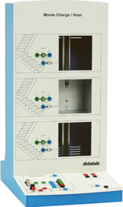
8 | 5 levels elevator model, 51 ON/OFF Inputs / Outputs, CAN OPEN cell control  Designed for the study of the sequential automatic process control with safety control :  Control systems :  - > By interpreter, Grafcet simulateur on PC,(steps, conditional actions, macro-steps, divergences, convergences..)  - > By PLC through 4 mm Inputs/Outputs sockets,  - > By PLC or any other control device, through CAN OPEN cell.  Inputs (PLC outputs) :  5 lights for level car presence, 5 lights for car call recording (passenger on the floor), 5 lights for car call recording (passenger inside the car), 1 light for emergency stop recording, 1 door opening control, 1 car up motion control, 1 car down motion control, 4 lights for up motion (level 0 to 3), 4 lights for down motion (level 4 to 1),  Outputs (PLC inputs)  5 level calls (car buttons), 4 car calls for up motion (level buttons), 4 car calls for down motion (level buttons), 1 car overweight detection, 1 emergency stop (car button), 5 door opening detections.  Provided with the simulator Grafcet Editor & Interpreter: "Mentorgraf" :  - Operation in execute mode with variable display.  - Grafcet graphic edition, steps, transitions, AND / OR divergences, macro steps, front conditional actions, internal variables, time delays, Master Grafcets, Slave Grafcets,  - Syntax errors processing & used variables coherence,  - Operation in simulation mode,  Supplied with books of practicals (teacher's book and student's book) | 2 | 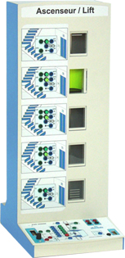
9 | TRAFFIC LIGHTS controlled by PLC  Operating part for the initiation to PLCs.  It can be used with a lot of PLCs (Schneider Twido, Schneider M340, Siemens S71200, Omron CP1E …).  The system has 19 Inputs and 6 Outputs  - 19 Leds (Grenn, Yellow, Red) with On/Off 24Vdc control  - 6 pushbuttons for pedestrian call or car presence simulation | 2 | 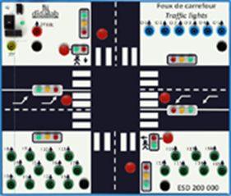
10 | Electropneumatic robot  The unit includes :  One electropneumatic robot moving on 5 axis (translation, forward/backward, up/down, rotation & gripper opening/closing, which totalizes 10 different controls (4 bistables & 2 monostables devices) & 11 sensors,  One plugging station having 1 bistable control & 3 sensors (piece presence , up & down positions of the jack),  One inflow store with pieces presence sensor,  One outflow ramp,  One flexible cell control device , totalizing :  Output: 2 operation modes, 1 emergency stop loop (emergency button, door opening, pressure loss),  Input: 1 pressure supply,  One system power supply board & one air conditioning set.  It is designed for demonstrating the control principle by pc computer, of a industrial automatic process (with Grafcet interpreter) or by PLC (by DB25 & DB37 connectors or inputs/outputs wiring…)  Supplied with books of practicals (teacher's book and student's book) | 1 | 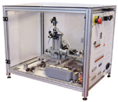
11 | PEDAGOGICAL BENCH FOR THE STUDY OF ELECTRICAL, PNEUMATIC, AND ELECTROPNEUMATIC technology  2 juxtaposed grid frames to be put on a table. This bench has been conceived for a very gradual training in the 3 automatic control parts : pneumatic, electrical, electropneumatic:  It includes :  - a set of electrical components for control,  - a set of pneumatic components for controln lot de composants pneumatiques de commande,  - components for electrical and pneumatic interface,  - an operating part in the form of simple or double acting cylinder and their sensors,  - 4-mm security sockets for the connection to external plc (for example).  - cdrom for practical works | 1 | 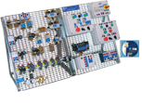
12 | A PEDAGOGICAL PLC, SCHNEIDER TWIDO  It includes:  14 inputs on/off  10 outputs on/off  Canopen master communication module. Bus link with a sub-d9 points connector. Bus limited to 16 slaves  Diam 4 mm- connections | 2 | 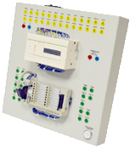
13 | PEDAGOGICAL PLC, SCHNEIDER M340  M340 Schneider PLC with a control unit, 31 inputs, 21 outputs relais, 1 I/O analogical simulation board  - 31 inputs linked to Sub-D37 connector, 16 of which linked also to ø 4-mm sockets  - 21 inputs linked to Sub-D25 connector, 16 of which linked also to ø 4-mm sockets  - 16 mini switchs for testing the 16 first inputs linked to Sub-D and ø 4-mm sockets  - 4 analogue inputs and 2 analogue outputs linked to ø 4-mm sockets  DB37 and DB25 connectors are used to control the pneumatic robot here above  - Master CANOPEN link (for the control of the lift)  - 1 Ethernet link (not web server) , USB lead (PC / PLC)  - Unity software (for installation in a computer (not supplied)) ; programmation of the PLC with LD, FBD, SFC, ST and IL languages  Technical notice | 2 | 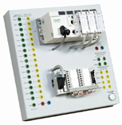
14 | S7-1200 PLC, training module,  - 14 On/Off inputs, with photo-coupler  - 10 0/24-Vdc On/Off outputs with transistors, with display,  - 1 0/10-Vdc analogue input,  - 1 12-bits analogue output, +/10 Vdc or 0-20 mA,  - 1 profinet (LAN) communication port,  - SFC graphic programming software  - the PLC is in a box with ø 4-mm security sockets and can be put on a table. | 4 | 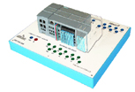
15 | WORKSTATION FOR SUTDENTS  - 1 electronic worktable, 200x100 cm, h 850 cm, feet  Work surface with high temperature protection,  Electrical panel : 16A circuit breaker, 30mA C curve differential circuit breaker, On/Off switch button, Emergency pushbutton; 3x3 electic plugs, 230V 16A,  - 2 seats | 8
16 | DESK COMPUTER  Core processor 2 dual 2,93 GHZ Intel, HD : 250 GB, 3Gbit/s, DRAM 1 GB DDR3, 8 USB ports, 3 X Ethernet, DVD r/w 16X, 19” screen, keypad, mousepad, Windows PRO | 8
17 | DIGITAL Oscilloscope, 100 mhz  2 X 100 MHz, TFT digital display, time base: 5ns to 50s, 500MS/s, Auto/normal/monocoup trigger, coupling A, DC, LF, HF, noise rejection, auto-calibration,  Supplied with 2 probes  150 MHz, ratio 1/1, 1/10, 10 MOhms, 10 to 30 pF | 8  8 | 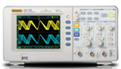
18 | hand Multimèter, 4000 points  Voltage: DC and AC up to 600 V  Current: DC and AC up to 10 A  Resistance : up to 40 MOhm | 2 | 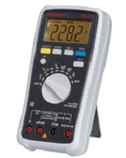
19 | LF function generator, wITH DIGITAL DISPLAY, 10 mHz 5 mhz,  Signals : sine, square, saw,  0 to 20 V pp without load, 0 to 10 V with 50 Ohms  Duty cycle adjustable between 20 to 80 % - intern wobulation: LIN or LOG  TTL output  Frequency meter up to 50 MHz | 2 | 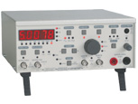
20 | Compressor, low noise,40 dBa, 8 bars, 3m3/h, 9l, accessories | 2
21 | BNC PATCH CORDS  BNC/BNC patch cords, 50 Oms, 1 m,  BNC/4-mm cords | 8  8
22 | CORdS  Set of 52 patch cords, insulated, PVC, stackable  Several lengths and colors | 8

