ITEM | DESIGNATIONS/CHARACTERISTICS | Qté | Picture
1 | trainer for the study of signal processing :  1 Module for signal processing based on doble core DSP.  Description of the Input and Output functions:  - 2 Broadband Inputs:  A/D pipeline converters, 16 bits 1 MHz, +/- 10Vdc.  - 2 Broadband outputs:  D/A converters 12 bits 100 KS/s +/-10Vdc  - 2 On/Off Inputs and Outputs,  - One set of connectors to connect the extension modules  - 2 HDMI connectors,  - 2 Codecs (Line in, Line out, microphone input, loudspeakers output),  Graphic and textual editor :  - Very large library (400 graphic functions, customizable (arithmetic, continuous, non linear, telecommunications, matrix, baseband, control, filters, etc.),  - Possibility of enriching the library by creating your own graphic functions,  - Switch from textual mode to graphic mode, multi windows,  - Immediate detection of errors (short-circuit, connections between 2 inputs, connections between incompatible modules,  Power supply : 240V  Set of accessories (USB patch cord, microphone, 2 stereo speakers, 2 BNC patch cords)  Supplied with booklets of practical works, with practical works about analogue electronics, digital electronics, analogue and digital modulations, analogue and digital filters …. | 8 | 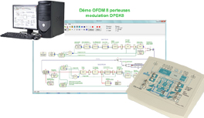

2 | OPTIONAL MODULES FOR THE STUDY OF ANALOGUE MODULATIONS, AM FM BLU EN HF ET VHF::  SDR Radio Transmitting Module, 27 MHz  Transposition of the IQ message with SDR technology (Sofware Defined Radio),"  Transmitting power (max) : 10 mW, Modulations and coding are processed with the basic module ETD410000,  The conversion of the signals is done with 24-bits 192-kHz CODECs  - Analogue and Digital Modulations, AM, FM, BLU,  - Digital Modulations : ASK, FSK, QPSK, QAM…  - Coding : AMI, RZ, NRZ, Manchester…  "Transposition of the IQ message with SDR technology (Sofware Defined Radio),  SDR Reception Module (LF, MF, and HF 27 MHz)"  Transposition of the HF to IQ IF with SDR technology (Sofware Defined Radio), Demodulations and decoding are processed with the basic module ETD410000,  The conversion of the signals is done with 24-bits 192-kHz CODECs  - Analogue demodulations, AM, FM, BLU,  - Digital demodulations : ASK, FSK,QPSK,QAM…  - Decoding : AMI, RZ, NRZ, Manchester… | 4 | 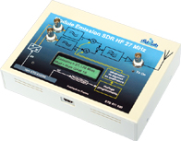  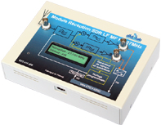
3 | ASK, PSK, BPSK, DPSK, QPSK, QAM digital modulations training monitors  Set Of 2 Monitors  - Sampling 7.5 Khz/8bits  - Inputs: Microphone, Lf Generator, Ttl Signals  - Transmission Means : Coaxial Cable, 2-Wires, Infrared, Radio And Optical Fibre  Transmission Monitor  - A/D & D/A Conversion, Sampling & Quantification, Pcm Signals  - Ask, Fsk, Bpsk, Dbpsk, Qpsk, Dqpsk Modultion  - Qam Modulation  Reception Monitor  - Ask Demodulation  - Fsk Demodulation, Pll,  - Démodulateur Bpsk, Dbpsk, Qpsk, Dqpsk And Qam Demodulation  - Supplied With Manual Of Practicals And Leads | 2 | 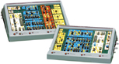

4 | TIME DIVISION SWITCHING UNIT  "The time-division switching training unit is dedicated to the experimental study of new-generation time division switching telephone exchange units.  It is based on the european standard PCM, 32 time channels, 2 Mbits.  This unit carries out the telephone connections between subscribers in local mode (1 exchange unit only) or between remote subscribers, through a ring network (several exchange units)."  The switching unit enables the study of new-generation telephone exchange units & its digital & analogue signals :  Signals displayed on the switching unit :  - Subscribers sets, (SLIC/CODEC) with synchronization signals (encoding of the A/µ law),  - Time Intervals, incoming PCM, outgoing PCM, 32 Time Channels in total, with standard flow of 2MB,  - Connection network (Conversation Time Memory, associated registers & control memory),  - Time base with all synchronization signals of Time Intervals PCM 32,  Remote communications :  - Study of ring remote communication,  - Study of HDB3 encoding & PCM transmission at the ETSI/UIT-T standard,  - Re-synchronization of remote time frames,  - Control of one semaphore channel, signalization protocole (Industrial Data Processing). | 2 | 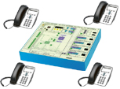
5 | Study and implementation of a Optical fiber link (Passive Optical Network)  ▪ Manipulation And Cleanliness Of A Signle-Mode Telecom Fiber.  ▪ Calibration Of The Power Meter.  ▪ Absolute (Dbm) And Relative (Db) Relative Measurements.  ▪ Research Of The Sensitivity Threshold Of The Receiver With The Adjustable Attenuator.  ▪ Measurement Of The Maximum Authorized Loss.  ▪ Study Of A Wdm Bidirectional Link.  1 base board enabling to contextualize an Internet Protocol through Optical Fiber (IP/OF) between a connected home and a remote supervision access. A silkscreen printing illustrates the Fiber To The Home link through Gigabits Passive Optical Network (FTTH /GPON) as well as a Point-to-Point link (P2P).  This base board includes :  - 1 IP / OF converter, wavelength : TX = 1550 nm, RX = 1310 nm,  - 1 OF/IP converter, wavelength: TX = 1310 nm, RX = 1550 nm.  3 silkscreen boards – to put in the center of the basis –illustrate the 3 main scenarios for the suggested practical  works:  - 1 Optical attenuation – Photometry board  - Absolute/Relative attenuation.  - Influence of the radius of curvature.  - Characterization of the optical fiber,  - 1 Optical Balance board  - Characterization of the fiber.  - Determination of the wavelengths.  - Emulation of a transmission channel.  - Determination of the maximum distance.  - Induced losses,  - 1 WDM bidirectional link board  - Implementation of an optical fiber multiplexing/demultiplexing.  - Consequences upon TCP/IP and UDP transmissions  - 1 Optical power meter for single-mode and multimode fiber, 6 calibrated wavelengths: 850, 1300, 1310, 1490, 1550, 1650 nm. Measurement of the absolute power ratio (dBm) and relative power ratio (dB). SC/APC connector  - Variable attenuator,  - IP camera  - Protective glasses, against laser, OD index >4 between 1000/1600 nm  Set of accessories : Connector cleaner, Carrying case Practical works. 1 | 2 | 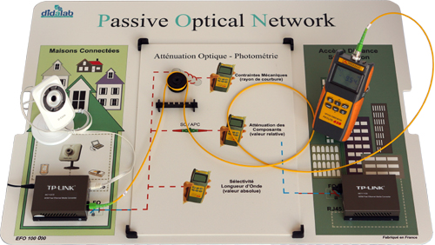
6 | Optical fusion splicer - Training kit  3-axis optical fibre fusion splicer, (with heating unit, loss estimation) ,  optical fibre stripper,  optical fibre cleaver,  carrying case,  heat shrink sleeves.  Supplied with Optical fibre, 900 μm, with SC/APC connector, L=10 m. | 1 | 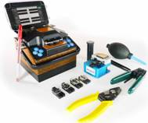
7 | « OTDR » : Refletometer  OTDR (Optical Time Domain Reflectometer), wavelengths: 1300 and1550 nm (single mode).  ▪ Determine The Defaults And The Causes For Quality And Flow Losses In Optical Networks.  ▪ Qualify An Optical Fiber Transmission Line.  Supplied with  150-m launch Fibre reel, with SC/PC connector.  Set of experimental components 1 Bobine amorce de 150 mètres avec connecteur SC/PC | 1 | 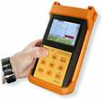
8 | Mechanical Splicing  Tool Box For Mechanical Splice With Stripper, Cleaver Tools, Red Laser, Cleaning Kit.  Training objectives:  ▪ Fiber Manipulatin And Preparation.  ▪ Cleaning, Stripping And Cleaving.  ▪ Mechanical Splice Setting: Transparent, Reusable For Fiber Connections.  ▪ Use of The Red Laser To Find Mechanical Stresses And Laser Alignment Aid. | 1 | 
9 | WORKSTATION FOR SUTDENTS  - 1 electronic worktable, 200x100 cm, h 850 cm, feet  Work surface with high temperature protection,  Electrical panel : 16A circuit breaker, 30mA C curve differential circuit breaker, On/Off switch button, Emergency pushbutton; 3x3 electic plugs, 230V 16A,  - 2 seats | 8
10 | DESK COMPUTER  Core processor 2 dual 2,93 GHZ Intel, HD : 250 GB, 3Gbit/s, DRAM 1 GB DDR3, 8 USB ports, 3 X Ethernet, DVD r/w 16X, 19” screen, keypad, mousepad, Windows PRO | 8
11 | DIGITAL Oscilloscope, 100 mhz  2 X 100 MHz, TFT digital display, time base: 5ns to 50s, 500MS/s, Auto/normal/monocoup trigger, coupling A, DC, LF, HF, noise rejection, auto-calibration,  Supplied with 2 probes  150 MHz, ratio 1/1, 1/10, 10 MOhms, 10 to 30 pF | 8 | 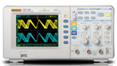
12 | hand Multimeter, 4000 points  Voltage: DC and AC up to 600 V  Current: DC and AC up to 10 A  Resistance : up to 40 MOhm | 4 | 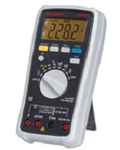
13 | FUNCTION GENERATOR, digital display 10 mHz 12 MHz,  Sine, square, saw,  Modulations : ASK, FM, FSK and PSK,  USB interface, display : 2x 16 signs  Protection : +/-60V and against short-circuits for the output | 8 | 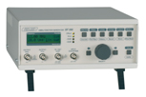
14 | SPECTRUM ANALYZER, 1 GHz:  Bandwidth : 150 kHz to 1 GHZ,  Display average noise level: <-135 dB ; phase noise : 80 dB/Hz at 10 kHz offset  Frequency resolution HF 3 kHz | 1 | 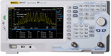
15 | RF generator:  Range 1 Hz 1200 MHz  Modulations AM/FM/PM/GATE/FSK/PSK  Output levels : -127 dBm/+13dBm, resolution 1 Hz. | 1 | 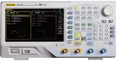
16 | PATCHING CORDS  BNC/BNC cords, 50 Oms, 1 m,  BNC/security Ø4-mm adapaters | 16  16

