ITEM | DESIGNATIONS/CHARACTERISTICS | Qty | photo
1 | STUDY OF VDI CONVERGENCE VDI & VOIP, 4 STATIONS)  Ce système est composé :  1 baie informatique12 Unités intégrant :  - 1 routeur 2 switchs, panneau de brassage, distribution d’alimentation avec protection différentielle,  - 1 serveur principale assure en autonomie de nombreux services assurés par un FAI (Fournisseur d’Accès Internet) serveur FTP, HTTP, films en VOD, en streaming, téléphonie SIP, ce serveur peut être administré via une IHM en face avant ou en distant par une interface HTML. 2 téléphones IP avec visio-conférence, il intègre toutes les images de réinitialisation de chacun des organes du réseau (serveurs, téléphones et PC étudiants, routeur switchs)  - 2 serveurs étudiants (2 binômes par serveur)  - 1 Set Top Box, interface IP HDMI avec son écran Full-HD,  - 1 Rack intégrant deux serveurs étudiants  4 Postes étudiants (4 binômes) incluant chacune :  - 1 PC sous Linux équipé d’un bouquet de logiciels libres permettant les analyses de trames Ethernet, logiciel de téléphonie logiciel par compte SIP, écran Full-HD, clavier, souris, micro-casque,  - 1 téléphone IP avec visio-conférence,  Manuel de Travaux Pratiques et vidéos pédagogiques traitants au moins les sujets de la convergence Voix Données Images (au moins 30 TPs).  STUDY OF VDI CONVERGENCE VDI & VOIP, 4 STATIONS  This system is made of :  -1 main cabinet with12 Units, including a server, router, switch, mixing panel and power supplies panel  The server gives (in complete autonomy) several services supplied by a ISP (Internet Service Provider), FTP, HTTP servers, VOD films, en streaming, SIP phones, this server can be managed via an HMI at the front or from a distance via HTML interface.  - 4 IP phones with videoconference,  - 4 PC with Linux with several freewares allowing the analysis of Ethernet chains, phone software, full HD screen, keyboard, mouse, headphones  - 1 Set Top Box, IP/HDMI interface with Full-HD screen,  Pedagogical booklets | 1 | 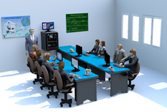  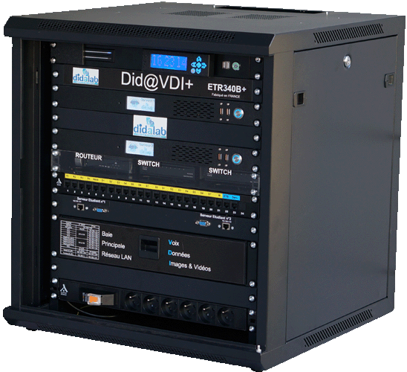
2 | ANTENNA STUDIES.  Set to study antennas  The bench includes:  ▪ A RF transmitting antenna base: 500 MHz, 2 GHz, 10 GHz, power level of about 10 mW, 50-Ohms adapted with 1-kHz FM modulation FM.  ▪ A receiving antenna base: -10 → -50 dBm, 0°/360° polarization, RS-232 interface, and 1 driver software on a PC.  ▪ A set of antennas: cornet, dipole, ring, patch, microstrip, helical, spiral...  ▪ The accessories, supply cords, practical works manual. | 1 | 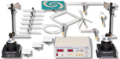
3 | Kit to study guided microwaves (9 TO 11 GHz)  COMPOSITION:  ▪ Microwave bench with Gunn oscillator, screw-in adapter, slotted line.  ▪ PIN modulator.  ▪ Crystal support, variable attenuator; waveguide, adapted load, directional coupler, hybrid "T".  ▪ power supply, 1kHz generator  ▪ storing case | 1 | 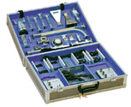
4 | STUDY OF DTTV AND SATELLITE TV BROADCAST (DVB-T &DVB-S),  Including HD field measuring instruments, a digital modulator, antennas …  -1 Autonomous encoder/modulator  for the broadcast with a coaxial networks in DVB-T (DTTV) format of HD audio/video signals. It includes a RF coupler  Video encoding : MPEG-4 AVC/H.264 ; HDMI interface  Resolution: 1920x080_60, 1920x1080_50 ; 1920x1080_60, 1920x1080_50, 1280x720_60, 1280x720_50  Audio encoding: MPED1 Layer II  Modulation: DVB-T standard COFDM, bandwidth: 6, 7, 8 MHz, constellation: QPSK, 16 QAM, 64 QAM  Coderate: 1/2, 2/3, 3/4, 5/6, 7/8, gard interval: 1/32, 1/16, 1/8, 1/4, transmission mode: 2k, 8k, MER>=42 dB  Frequency: RF 30- 960 MHz, 1 kHz steps  Output levels: RF -16 _ -36 dBm (71_9 dBµV), 0.1 dB steps  -1 set of 2 DTTV antennas (on stand with conection cables)  - 1 parabol antenna with 30-m cable  -1 field measuring instrument  RF input, with F female connector, 75 Ohm, display screen (TFT 7" ; 16:9)  External Terrestrial band : 5, 12 and 24 V, external Satellite band : 13V, 15V, 18V  Measuring mode :  DTTV: DVB-T COFDM, DVB-T2 Base and Lite COFDM, DVB-C QAM, DVB-C2 COFDM, spectrum analyzer  - 1 mini-PC with Windows  CPU dual core 1.8 G, 6 USB, 1 LAN, HD: 320 GB, RAM: 2 GB, powersupply, porgrams for the audio and video  1 21.5" screen, HD, HDMI, webcam embedded  Set of accessories: 3 HDM cables, 1 VGA, HDMI 2 ways splitter, micro and headphone  - 1 TV  Full HD, 48", BNC/TV trasfer, BNC "T" | 2 | 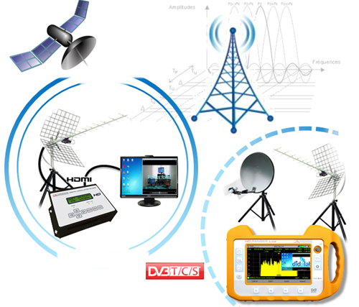
5 | WORKSTATION FOR SUTDENTS  - 1 electronic worktable, 200x100 cm, h 850 cm, feet  Work surface with high temperature protection,  Electrical panel : 16A circuit breaker, 30mA C curve differential circuit breaker, On/Off switch button, Emergency pushbutton; 3x3 electic plugs, 230V 16A,  - 2 seats | 8
6 | DESK COMPUTER  Core processor 2 dual 2,93 GHZ Intel, HD : 250 GB, 3Gbit/s, DRAM 1 GB DDR3, 8 USB ports, 3 X Ethernet, DVD r/w 16X, 19” screen, keypad, mousepad, Windows PRO | 1
7 | swR meter  Input frequency: 1000 Hz, range : 70 dB (2 and 10 dB steps) | 1
8 | Power meter  range: 0.01/12.4 GHz,  Power range: 0/99.9 mW peak 1W 1s, | 1

