ITEM | DESIGNATIONS/CARACTERISTIQUES | Qté | REF et Visuel produit
1  1.a | SELF-OPERATED LABORATORY (from 1 to 8 workstations), DEVELOPMENT OF THE VDI CONVERGENCE & NETWORK ARCHITECTURE  The laboratory includes:  - Pre-fitted cabinet for 8 workstations + STB , 12Units, locking sides & door, including:  - 1 Router with 4 LAN ports LAN, 1 WAN port, Wifi bridge, for IGMP snooping,  - 2 Switches with 4 ports, for IGMP snooping  - 1 mixing panel, 2 U (23+10 ports), marked off & equipped of RJ45 crossbars,  - 1 panel for power supply and electrical protection,  - 1 Dida-VDI++ network emulator, SIP, RTSP, IGMP, HTTP, FTP server, IHM by drop-down menu. This server can supply a lot of the different services supplied by a Internet Service Provider (ISP). It includes all the back-up files for the "re-start" of the students servers and computers, the back-up for the Setup Box too.  - 1 IP/HDMI Set Top BOX Interface with remote control, keyboard and UTP cables.  - 1 21,5" HDMI screen with webcam and loudspeakers,  - 2 IP telephones with video-conference, 4,3" colour screen  - Pedagogical films, MCQ on VDI and networks. | 1 | ETR400B  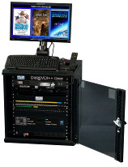
1.b | - DidaVDI++ & network architecture development workstation, in the form of a 6 unit cabinet including :  - 1 Router with 4 LAN ports, 1 WAN port, Wifi bridge, for IGMP snooping  - 1 Switch with 8 ports, for IGMP snooping  - 1 mixing panel, 1U, marked off & equipped of UTP crossbars, HDMI USB  - 1 panel for power supply and electrical protection,  - 1 Server with Linux and a set of freewares to configure (SSH server, FTP server, HTTP server , IPBX server, Video-surveillance server, IPTV server...)  - 1 IP/HDMI Set Top BOX Interface with remote control, keyboard and UTP cables. | 8 | 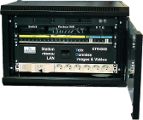
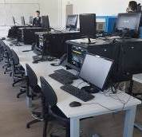
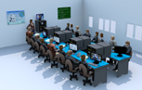
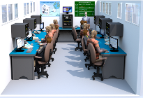

1.c | - Computer with Linux and a set of freewares:  - Nmap : state of TCP and UDP services . Ngrep : Analysis of the TCP UDP packets,  - FTP clients, FileZilla: Transfer of FTP files ,  - Iceweasel : Internet explorer,  - Ekiga : Softphone for computer,  - VLC : Multimedia reader,  - Wireshark : networks protocoles analysis | 8 | 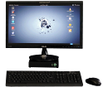
1.d | - IP telephone with video-conference,  4,3" LCD color screen,  video camera (CMOS 1,3 Mpixels codec video H.264, H.263 compatible, Wifi  . | 8 | 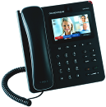
 | - Set of Manuals of Practical Works, pedagogical video (put in the server)  Examples of Practical Works  - Discovery  - Networks Architecture,  - XDHCP, ARP Protocoles  - Configuration of a switch, a router  - XFTP, HTTP, RTSP/IGMP, SIP and RTP Protocoles (configuration), SIP et RTP (analysis)  - Advanced training (creation of services) :  - Setting a local networks,  - Physical segmentation of a level 2 VLAN , a level 3 VLAN  - IP TV – Web Video & STB client Services ,  - IP TV – Digital video recorder services, media center client,  - Video-surveillance Service ,  - Implementation of a Vidéo server , Streaming and VOD,  - IPBX VoIP calls,  - Implementation of Asterisk Server, XPHP/MySQL Server.  Installation and commissioning of the laboratory in the university / training centre  Installation for min 2 days  Users training for min 2 or 3 days  There is no furniture in our proposition (we will supply a setting plan with minimum dimensions …)  ALL POSITIONS CONSTITUTE A LABORATORY. THEY CANNOT BE SEPARATED. THE OFFER IS ONLY VALID IF ALL THESE ITEMS ARE TAKEN AT DIDALAB.  THE STUDENT STATIONS CAN RANGE FROM 1 TO 8 (SAME QUANTITY FOR POSITIONS 1.(b,c,d).THE MAIN CABINET (1.a) ALWAYS REMAINS IN QUANTITY 1 |   1 |   

